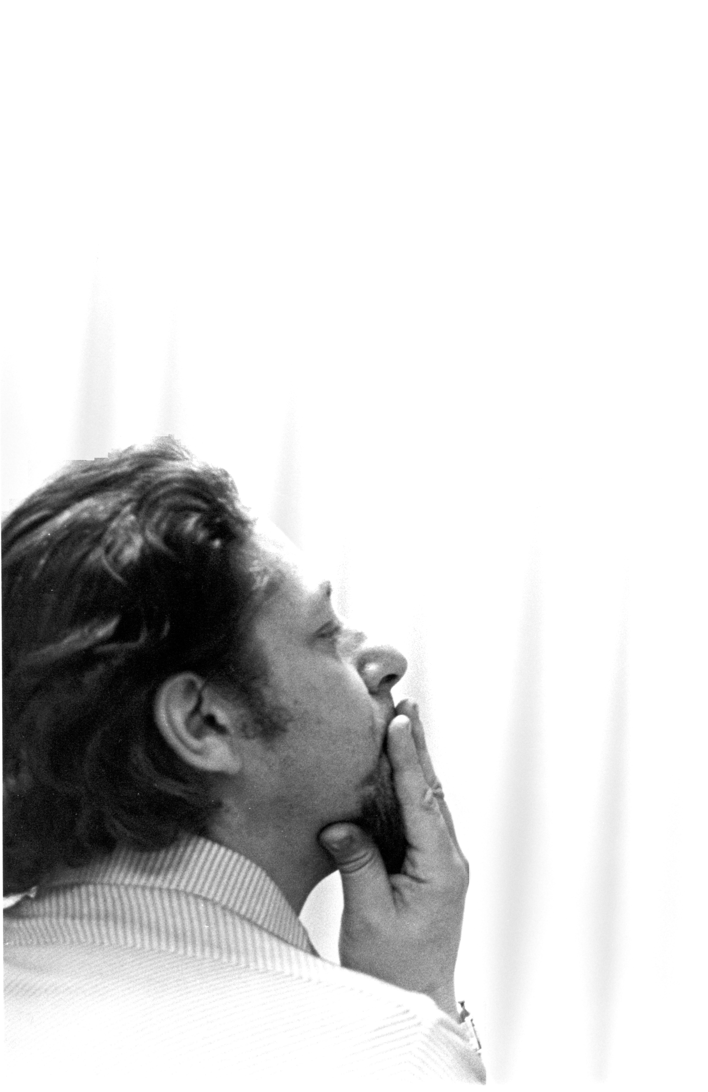
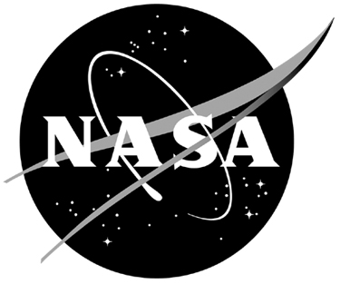
National Aeronautics and Space Administration

NASA ACADEMY
GODDARD SPACE FLIGHT CENTER

PROFILE BOOK

Profile Book
2008 NASA Academy
Goddard Space Flight Center

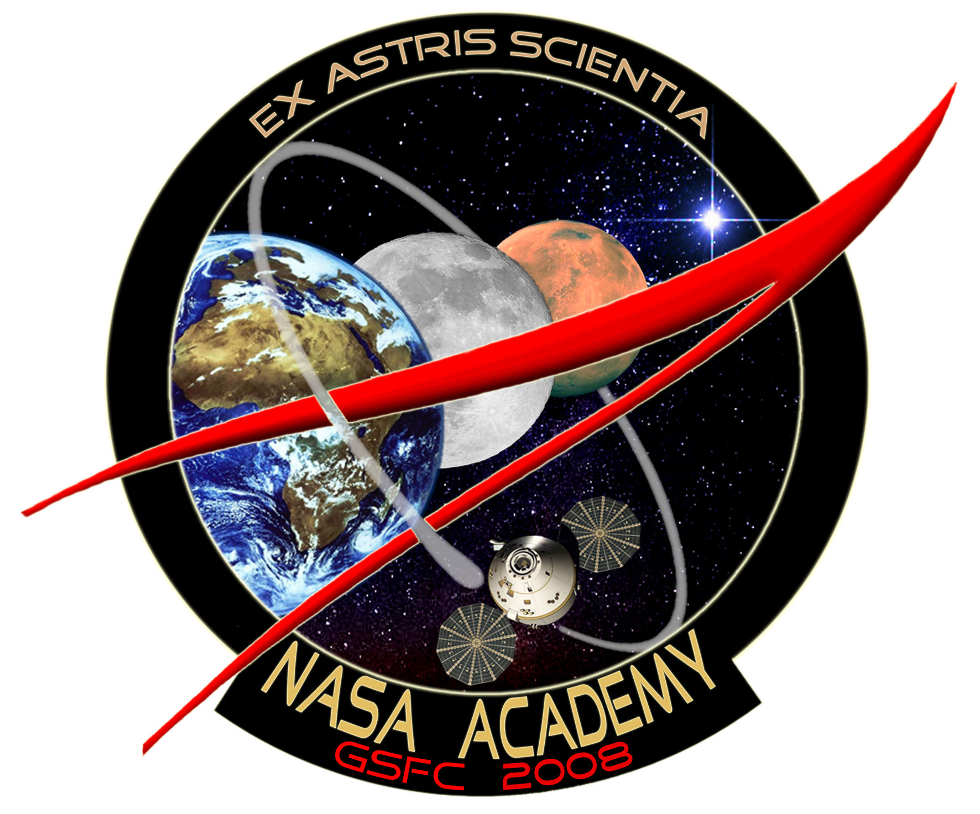

University Programs Office, Mail Code 130
NASA Goddard Space Flight Center
Greenbelt, MD 20771
http://academy.gsfc.nasa.gov/2008

University Programs Office, Code 130
Table of Contents
Program Description 1
A Brief History of the NASA Academy 3
Jennifer Allen 5
Andrea Balbas 7
Bradley Cheetham 9
Jennifer Founds 11
Brandon Hall 13
Juan Lora 15
Andrew McDonald 17
Tony Mercer 19
Kenji Nagaoka 21
Florent Nobelen 23
Michelle Perez 25
Maxime Rizzo 27
Lisha Roubert 29
Andrew Schaeperkoetter 31
John Springmann 33
Michelle Sybouts 35
Alan Talbott 37
Jessica Tramaglini 39
Zhen Zhao 41
Program Coordinators 43
Staff 44
Links 46

Program Description
The NASA Academy is an intensive summer leadership program of higher learning for college undergraduate and graduate students interested in pursuing professional careers in space-related fields.

Designed to present a comprehensive package of information and experiences about NASA, the NASA Academy exposes its students (Research Associates, or RA’s) to the agency’s most important current and planned science, engineering, education, and technology enterprises. It also offers training in non-technical areas such as: management, budgeting, safety, personnel and career development, leadership, space law and international cooperation. Besides attending lectures and workshops, RA’s are involved in supervised research in GSFC laboratories and participate in visits to NASA Headquarters, various NASA Centers and facilities, the Applied Physics Laboratory, and other space-related academic laboratories and industries.

A Brief History of the NASA Academy
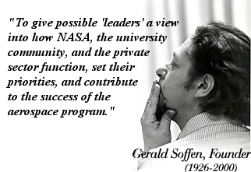
The NASA Academy was founded in 1993 (as the "NASA Space Academy") at the Goddard Space Flight Center by Gerald (Jerry) Soffen, former Mars Viking project scientist, architect of the NASA Astrobiology program, and first Director of the Goddard Office of University Programs. Jerry was an accomplished scientist and dedicated educator. He took advantage of the unusual opportunities presented to him during his career and realized the importance of mentoring in the life of young professionals. In his vision, the Academy was intended to exceed in purpose and content all other internships by familiarizing its participants with as many facets of NASA as possible. With his dynamic personality and unique leadership, he opened many gateways and defined a new standard of excellence.

As the reputation of the Goddard Academy widened, new NASA Academy Programs were started at Marshall Space Flight Center (1994), Ames Research Center (1997), and Dryden Flight Research Center (1997). The name of the program changed from "NASA Space Academy" to "NASA Academy" at specific NASA Centers. A continuous effort is being made to establish or re-establish Academies at various Centers, with different profiles and focus areas. In 2008, NASA Academies will take place at Goddard, Glenn, Ames, and Marshall.
There have been several international participants in the NASA Academy from England, Canada, Italy, Germany and France. The 2008 Academy will host five international students including two French, one Romanian, one Canadian and one Japanese student.
Jerry Soffen died on November 22, 2000. We honor his legacy by continuing the Academy program he loved so well. In 2008, the NASA Academy will celebrate sixteen years of successful activity. To date, over 600 participants (or alumni) have graduated from the program of which many are actively involved with NASA, the space industry and the Academy.

Jennifer Allen
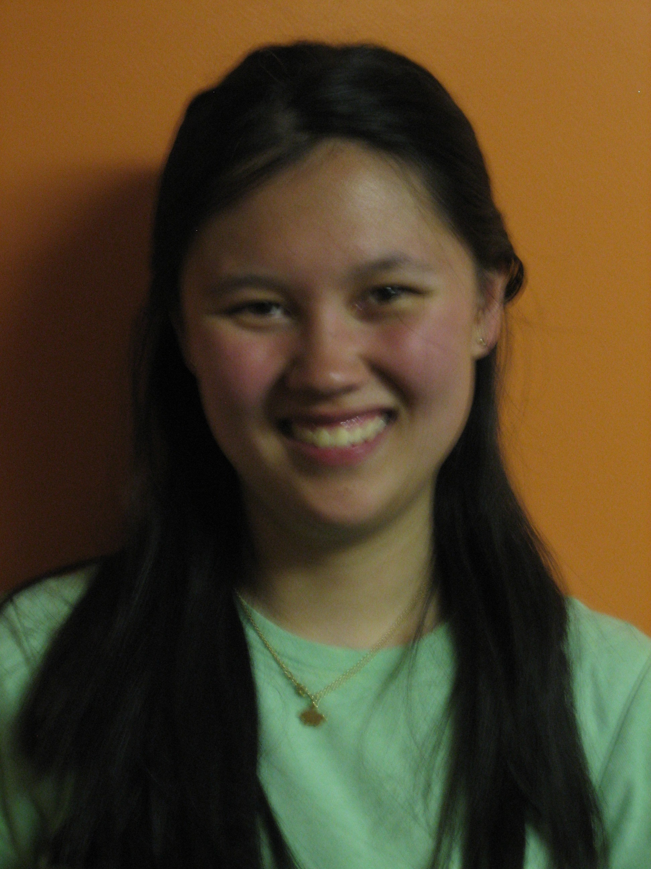
Massachusetts Institute of Technology
Cambridge, MA
Aeronautics and Astronautics
Bachelor of Science, June 2010
Email: jenallen@mit.edu

NASA Academy Research Project:
Project Title: GOES Weather Satellite System Data Analysis
Principal Investigator: Kenneth Yienger, Code 599
Work Experience
- Intern in MIT’s Aerospace Controls Laboratory
- Participant in the NASA Ames Research Center Robotics Academy
- Intern in MIT’s BioInstrumentation Laboratory
- Grader for Physics I
- Tutor and Science Teacher for the Breakthrough Collaborative
- Intern in the University of Texas at Austin’s Center for Space Research Center
Memberships and Activities
- MIT Varsity Women’s Fencing – Sabre, 2006-present
- Dormitory Student Government Representative, New House-Desmond Social Chair, 2007-present
Skills and Certifications
- Computer Skills: Microsoft Office, Matlab, Eclipse, SolidWorks, ExpressPCB; Languages: Java, C++, C, Python
- Language Skills: Conversational Mandarin Chinese (reading, writing, speaking) and English
- RC Aircraft Piloting
Hobbies and Interests
Writing, Reading, Fencing, Knitting, Watching the Stargate Series, Running, Standing in the Rain, Spending time with friends, Exploring the Outdoors through hiking, camping, backpacking, rock climbing, caving
Personal Statement
“From the moment I first saw the images from the Hubble Telescope as a small child, I fell in love with space. Now a little older and perhaps a little wiser, I dream of a career spent on the frontlines of space exploration, particularly in the development of autonomous space vehicles. I am a rising junior in the Aeronautics and Astronautics department at the Massachusetts Institute of Technology, intending to major in Aeronautics and Astronautics with Information Technology and to minor in Chinese Language. I love opportunities to apply my studies in a practical setting, and see this summer as a perfect opportunity to expand my practical skills. I am honored to have again received the opportunity to intern at a NASA facility and pursue my dreams of space exploration.”

Andrea Balbas
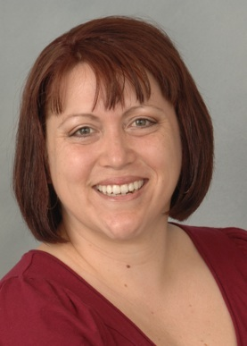
Queens College CUNY
Queens, NY
Geology
Bachelor of Science, December 2009
Email: andrea_balbas@yahoo.com

NASA Academy Research Project:
Project Title: Digital Beamforming Synthetic Aperture Radar Imager and Altimeter
Principal Investigator: Rafael Rincon, Code 555
Research Experience
Conducting research: Holocene Climate and Anthropogenic Changes in Long Island Sound, NY
- Document estuarine sediment contamination in western Long Island Sound and develop a chronology to evaluate its impact
- Use physical property comparisons such as bulk density and magnetic susceptibility to understand sedimentation trends
Program sponsored by NSF-OEDG
Measured: short-lived radioisotopes, C-14, and heavy metal concentrations
Goal: To present results at a national meeting and publish in “Journal of Coastal Research”
Memberships and Activities
- Student Member American Institute of Professional Geologist (2006 to present)
- Student Member SACNAS (2007)
- MSPHD (Dec. 2007 to Present)
- Student member AGU (Dec. to Present)
Skills and Certifications
Microsoft Office Suite and Optical Mineralogy
Honors and Awards
- Dean’s List: 4 semesters
- Hispanic Scholarship Fund Award: Fall 2006- Spring 2007
- Queens College Writing Award: Spring 2006
- Ruth Rudovsky Award: Tuition Assistance Spring 2007 – Fall 2008
- MSPHD Cohort - 2007 to present
Hobbies and Interests
Hiking, fossil hunting, field geology, researching possible lithospheric anomalies caused by forces outside our planet
Personal Statement
I am inspired to reveal more of our universe’s history via tests and measurements of our lithosphere. I believe with a lifetime of work, good partners, and continued motivation I can define time periods of increased radiation in our earth’s past. I plan to test sediments, as well as metamorphic and igneous rocks. Additionally, I intend to couple my data collection against paleomagnetic records and extinction events. I am inspired by the difficulty of this project and the story it may tell us about the birth and death of numerous stars that may have shaped our biosphere.

Bradley Cheetham
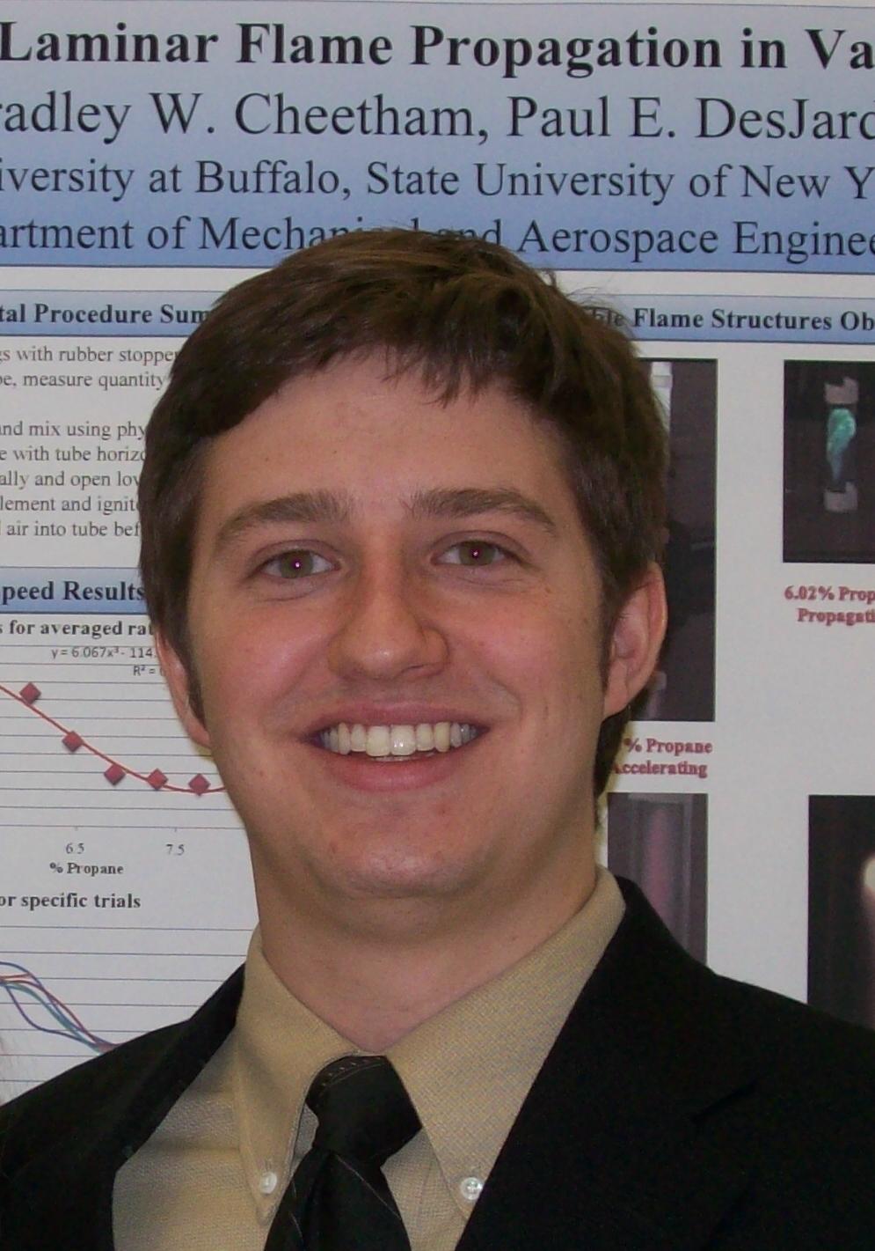
University at Buffalo
Buffalo, New York
Mechanical and Aerospace Engineering
Bachelor of Science, June 2009
Email: brad.cheetham@gmail.com
Website: www.eng.buffalo.edu/~cheetham

NASA Academy Research Project:
Project Title: Lunar Mission Design Using WSB
Principal Investigator: David Folta, Code 595
Work Experience
- Lunar Excavator Design and Analysis. Independent research (‘07-‘08)
- Laminar Flame Speed Investigation. Independent research (Sp. ‘07)
- Community Assistant. University Apartments (Sp. ’07 – present)
- Tour Guide and Prospective Student Host. University Honors College (Sp. ’06 – present)
- Student Teaching Assistant. Engineering and Applied Science Lab (Fall ’06)
- Collegiate Tennis Official. (Sp. ’04 – present)
- Hotel Front Desk. Country Inn & Suites, Cortland NY (Fall ’03-Sp.’05)
Memberships and Activities
- UB Students for the Exploration and Development of Space. President & co-founder (Sp. ’07 – present)
- Tau Beta Pi Engineering Honor Society NY Nu chapter. Vice President of Internal Affairs (Sp. ’08 – present)
- Pi Tau Sigma Mechanical Engineering Honor Society. (Sp. ‘07-present)
- Space Exploration Alliance. Director of Student Relations
- American Astronautical Society. Member
- American Society of Mechanical Engineers (ASME). Member
- American Institute of Aeronautics and Astronautics (AIAA). Member
- National Space Society (NSS). Member/volunteer
- United States Tennis Association, Eastern Tennis Umpires Association
- www.explorerfish.com exploration news website. Creator and executive editor
Skills and Certifications
- Computer Skills: Microsoft Office, AutoCAD, Wildfire Pro-E 2.0, SolidWorks, Maple, Matlab, Joomla
- Language Skills: Coursework in Spanish. Exposure to Spanish, French, German, and Greek language and culture.
Honors and Awards
- University Honors College. Honors Scholar (Fall ’05 – present)
- 2008 Barry M. Goldwater Scholar.
- University Excellence in Research Award for Exemplary Work in Undergraduate Research and Scholarship (Sp. ’08)
- Provost’s Acknowledgement of Outstanding Academic Achievements and Intellectual Ambition. (Sp. ’08)
- Center for Undergraduate Research and Creative Acts (CURCA) Research Award (Sp. ’08)
- Dean's List. All semesters
- NASA Space Grant Fellowship (’07-’08)
- Zimmer Undergraduate Research Award (Sp. ‘07)
- SEDS-USA Local Executive Board Member of the Year (‘07)
Hobbies and Interests
Everything space is a hobby or interest. I love most kinds of music and listen to it all the time. I enjoy tennis, soccer, golf, downhill skiing, water skiing, and tubing. The little free time I have I spend hanging out with my friends and having a good time. I try to take life lightly and I’m quick to crack a joke in most situations.
Personal Statement
I’m a very motivated and busy person. I’m optimistic about the future and believe that humans must scientifically explore and responsibly develop space. In my opinion our future depends on it. For this reason I plan to devote my career to doing what most people think is impossible. I hope that I can forever dream big, ask for help when needed, and never give up. Last year, working with an extremely motivated NASA Academy Alum I founded a chapter of Students for the Exploration and Development of Space (SEDS) at the University at Buffalo. Since then I have been involved with Yuri’s Night, the world’s party for space, as well as the Space Exploration Alliance, and I cannot wait to contribute to NASA Academy this summer. I plan to pursue graduate studies in a space related field and contribute to the advancement of space exploration and its inevitable commercial development.

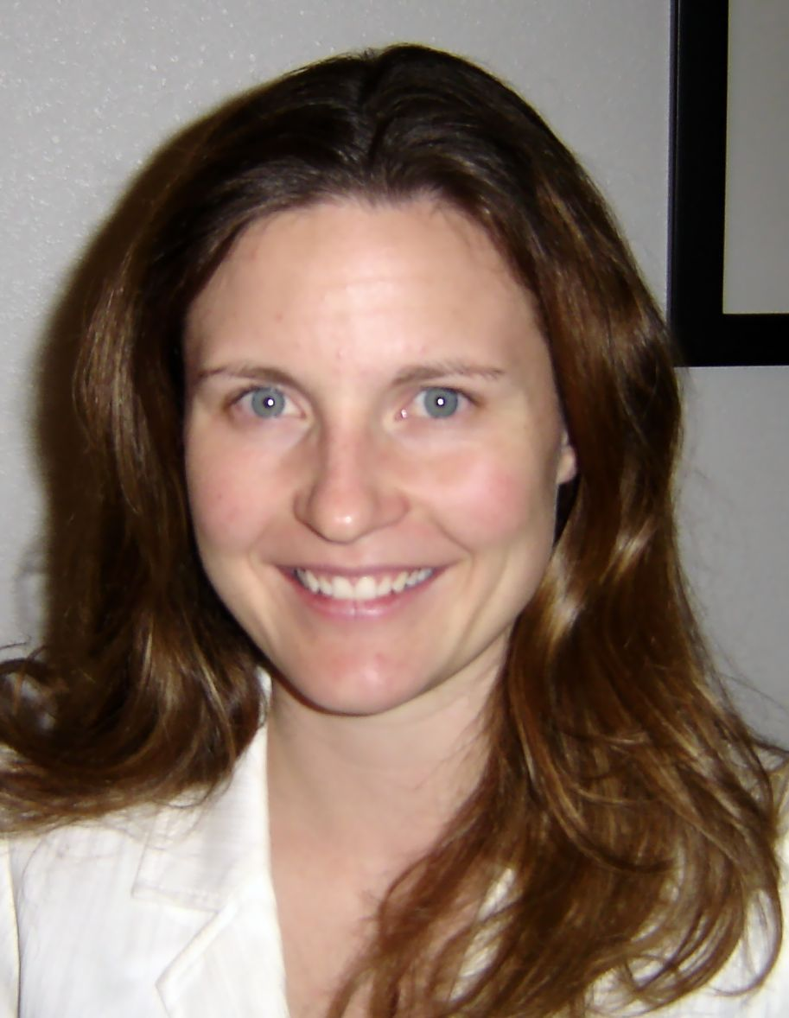
Jennifer Founds
University of Idaho
Moscow, Idaho
Electrical Engineering
Master of Science, December 2008
Bachelor of Science cum laude, May 2007
Email: jfounds@vandals.uidaho.edu

NASA Academy Research Project:
Project Title: JWST: Controller Design for a
Magnetically Suspended Chopper Wheel
Principal Investigator: Kenneth Lee and Scott Schwinger, Code 544
Research and Work Experience
- Research Assistant - Microelectronics Research and Communications Institute - Design and supervise undergraduate team designing integrated power electronic circuits (Fall 2005 – present)
- Space Grant Engineering Intern - NASA Jet Propulsion Lab – Design integrated electronics for mass spectrometer (Summer 2007)
- Senior Design Team Lead – University of Idaho NASA RLEP – Design and build proof-of-concept robot for non-prehensile manipulation (Fall 2006-Spring 2007)
- Product Engineering Intern - Micron Technology Inc. – Test and analyze defective CMOS image sensors to create validate solutions for customer problems (Summer 2006)
- Engineering Intern - Applied Technology Associates – Create simulation environment to collect gyroscope data (Summer 2005)
- Poster : Founds, J., H. Hess, E. Mentze, K. Buck, M. Richardson “High-Voltage Series MOSFET Output Driver for Nanometer Technologies”, International Planetary Probe Workshop 5, Bordeaux, France June 2007
- Paper and oral presentation: Founds, J., H. Hess, E. Mentze, K. Buck, M. Richardson, "High-Voltage Switching Circuit for Nanometer Scale CMOS Technologies”, 13th NASA Symposium on VLSI, Post Falls, ID May 2007 <http://www.cambr.uidaho.edu/ symposiums/13TH_NASA_VLSI_ Proceedings/index.htm>
Memberships and Activities
- Electrical and Computer Engineering Senator for Graduate and Professional Student Association (GPSA), Fall 2007 – Present
- GPSA representative for University of Idaho Graduate Council, Fall 2007 – Present
- Tau Beta Pi Engineering Honors Society (Idaho Alpha Chapter), President Spring 2006-Spring 2007, Member Spring 2005 - present
- IEEE Member
Skills and Certifications
- Integrated Circuit CAD Tools: Cadence™, Silvaco®, LTSPICE
- General Engineering Tools: MATLAB®, MathCAD®, LabVIEW®
- Integrated Circuit Testing Skills: Integrated Circuit Probe Stations, Semiconductor Parameter Analyzers
- ITAR Certified
- SCUBA Certified ( May 2008)
Honors and Awards
- Fred A. & Clare C. Skina Scholarship (Fall 2007-Spring 2008)
- University of Idaho Alumni Award for Excellence (December 2006)
- Micron Technology Inc. Scholar Award and Scholarship ( Fall 2005- Spring 2007)
- Dean's List, 2003-Present
Hobbies and Interests
Swimming, Soccer, Camping, Fly Fishing and Fly Tying, Woodturning, Scuba Diving, Snowshoeing, Reading
Personal Statement
With both parents having aerospace degrees, you could say I have aerospace in my blood. In elementary school, my fifth grade class created a human habitat for Mars as part of the Air Force Marsville Program. Since then I’ve been intrigued by the idea of building human habitats in space. As I entered college, I chose to study electrical engineering with the hope that I could use my degree to improve the quality of life for people by helping develop the next generation of technologies. The goal of my undergraduate senior design project was to design and build a robot concept that would precede human lunar missions. Last summer, I worked with engineers at the Jet Propulsion Lab to design the electronics to power a mass spectrometer that would analyze the air in the International Space Station. I am confident my experiences at the NASA Academy will continue to fuel my enthusiasm for space exploration and the connections and knowledge gained will serve as a foundation for a career in space technologies.

Brandon Hall
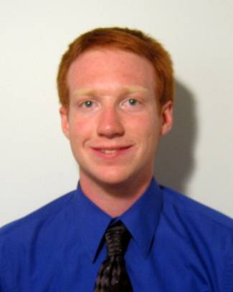
University of Maryland
College Park, MD
Aerospace Engineering
Bachelor of Science, May 2010
Email: hall@umd.edu

NASA Academy Research Project:
Project Title: A Dust Mitigation Vehicle
Principal Investigator: Eric Cardiff, Code 597
Work Experience
- GSFC Student Internship Program, Summer 2007
- Part-time Dust Mitigation Vehicle Research Project at GSFC
- Clark School Ambassadors Program
Memberships and Activities
- AIAA Student Member
- Member of Sigma Gamma Tau Aerospace Honor Society
- University of Maryland Microgravity Research Team
- University of Maryland Gemstone Program,
- University of Maryland Honors Program
- SAMPE Composite Wing Competition
- University of Maryland Aerospace Engineering Honors Program
Skills and Certifications
- Computer Skills: Microsoft Office, Matlab, C++, PHP, Solid Edge, COMSOL, Linux, Autodesk Inventor
Honors and Awards
- Northrop Grumman Engineering Scholar’s Award
- Dean's List, four semesters
- Maryland Distinguished Scholar
- Joseph Guthrie Memorial Scholarship
- Thomas and Christine Li Endowed Scholarship
Hobbies and Interests
Keeping up with the latest space news, science fiction, fishing, boating, discovering delicious foods, and human spaceflight
Personal Statement
"I feel incredibly privileged to have the opportunity to work at Goddard Space Flight Center. I participated in the Student Internship Program (SIP) during the summer of 2007 and it was an outstanding experience. Not only did I learn a lot about the engineering process, I met a lot of permanent employees and interns who made the experience an absolute pleasure. I have had the chance to continue with my research project since then. Goddard is a great place to be and I am truly excited to be returning for the summer. It is extremely rewarding to be surrounded by a group of enthusiastic and dedicated people who share your goals. I am looking forward to NASA academy and hope that I can make a significant contribution during the summer."

Juan Lora
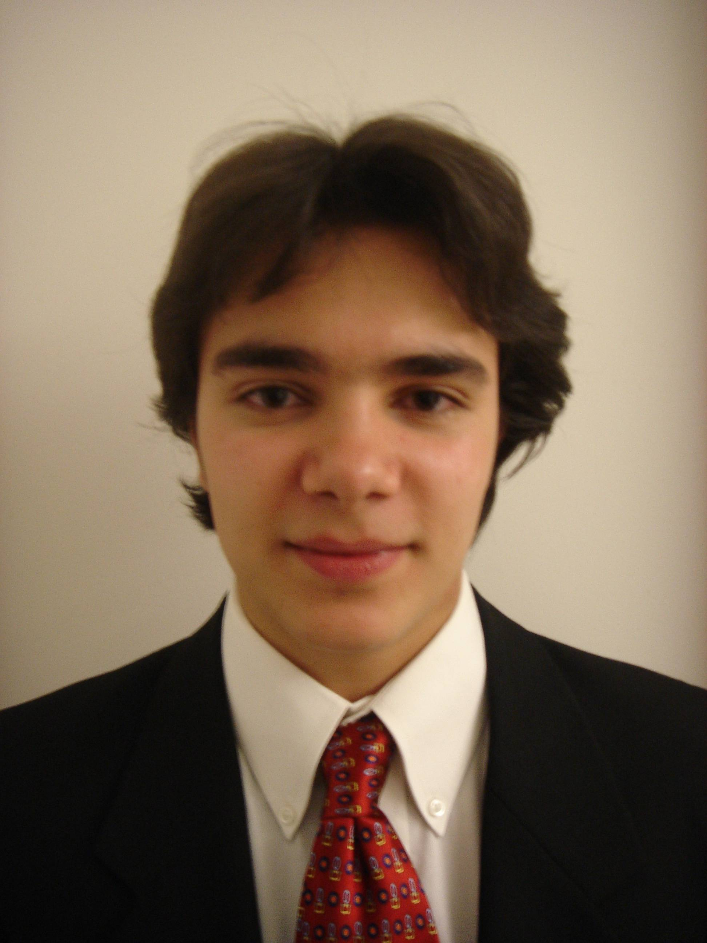
University of Southern California
Los Angeles, California
Astronomy
Bachelor of Science, May 2009
Email: jlora@usc.edu

NASA Academy Research Project:
Project Title: Technology Development for Cosmic
Microwave Background Polarimetry
Principal Investigator: David Chuss, Code 665

Research and Work Experience
- USC Helioseismology Group, Undergraduate Researcher
- USC Helioseismology Group, Undergraduate Research Coordinator and Instructor for New Researchers
- USC School of Cinematic Arts, Violinist in Recording Sessions
Memberships and Activities
- Phi Beta Kappa Honor Society, 2008-Present
- USC Symphony, 2006-2007, 2007-2008 seasons
- USC Society of Physics Students, 2007-Present
- USC Concert Orchestra, Spring 2006 (Principal Second Violin)
- Alpha Lambda Delta Honor Society, 2006-Present
- Walt Whitman High School Symphony, 2003-2005
  - Concertmaster, 2004-2005 season
  - Principal Second violin, 2003-2004 season
- 1st violin section in Maryland All-State Senior Orchestra, 2004
- NSO Young Associates’ Member, 2003-2004
- Youth Fellowship Quartet, 2002-2003
Skills and Certifications
- Computer Skills: Unix, Macintosh, Windows Operating Systems; MS Word, PowerPoint, Excel; limited Matlab, Mathematica, Adobe Photoshop, Illustrator
- Language Skills: Fully Bilingual English/Spanish
Honors and Awards
- USC College Dean’s List, Fall 2005, Spring and Fall 2006, 2007
- Dean Joan M. Schaefer Scholarship, 2007, 2008
- Albert Fisher Science Scholarship, 2007
- Latino Honor Society Gold Scholar Award, 2006
- Outstanding Academic Excellence by the President’s Education Awards Program, 2005
- Scholar in 2004-2005 National Hispanic Recognition Program
- National Merit Scholar, 2004-2005
- AP Scholar with Honor Award, 2005
- National Foundation for Advancement in the Arts Merit Award, 2004, 2005
- Scholastic Art Awards Gold Key Winner, 2002
Hobbies and Interests
Astrophysics, planetology, astrobiology, space exploration, playing violin and piano, painting, music, cinema, soccer and football, literature and travel.
Personal Statement
“My interest in science began as a child. Although my education through high school focused primarily on the arts, I was widely exposed to science, and have now chosen to pursue astronomy (or planetary science) as a career. I am fascinated by the interdisciplinary nature of the work involved in studying the universe. Currently, my research at USC involves solar physics, but I am particularly interested in astrobiology and comparative planetology. Upon graduation from USC in 2009, I expect to begin PhD studies in one of these fields with the intention of becoming a full-time researcher. Meanwhile, I continue to study music with a minor in violin, during which I have had the opportunity to play under the baton of John Williams, and alongside renowned soloist Midori. I hope that my experiences in the arts inspire creativity in my future scientific endeavors.”

Andrew McDonald
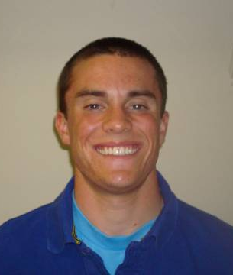
University of Florida
Gainesville, Florida
Mechanical Engineering
Bachelor of Science, May 2009
Email: andrew.j.mcd@gmail.com

NASA Academy Research Project:
Project Title: JWST: Redesign and Modification of
the Micro Shutter Flight Hardware
Principal Investigator: Scott Schwinger, Code 544
Work Experience
- NASA Reduced Gravity Student Flight Opportunities Program – Team Lead, “Applications and Limitations of Ionic Polymer-Metal Composite Sensors and Actuators in Space”, 2008
- NASA USRP – Johnson Space Center – Mission Operations Directorate Intern, Summer 2007
- University of Florida – Undergraduate Research Assistant, Micro Air Vehicles Laboratory/Experimental Stress Analysis Laboratory, 2007-2008
- University of Florida – C++ Teacher’s Assistant/Grader, 2006-2008
- Rehrig Pacific Company – Mechanical Engineering Intern, Summer 2006
Memberships and Activities
- Tau Beta Pi – Florida Alpha Chapter (2007 – present)
- Pi Tau Sigma – Sigma Omicron Chapter (2007 – present)
- American Society of Mechanical Engineers (2007 – present)
- University of Florida Student Honors Organization (2005 – present)
Skills and Certifications
- Computer Skills – Microsoft Office, Pro ENGINEER, AutoCAD, Autodesk Inventor, C++, MATLAB, LabVIEW
- Technical Skills – Lean Manufacturing, 5S System
Honors and Awards
- 2008 University of Florida MAE Undergraduate Research
Symposium – 1st place
- College of Engineering Dean's List – all semesters attended
- University of Florida President’s Honor Roll (4.0 semester GPA) – 3 of 5 attended semesters
- University of Florida Anderson Scholar with Distinction
- Florida Bright Futures Scholarship (2005 – present)
- EADS / Airbus NA Scholarship (2008 – 2009)
Hobbies and Interests
Golf, basketball, baseball, football, reading, wakeboarding, relaxing on the lake, space, NASA, anything adventurous, traveling, flying, driving, running, cycling, spending time with my family, eating, skydiving.
Personal Statement
"My love for NASA and space research began at age 12 when I first heard the sonic boom of the Space Shuttle upon reentry to the earth’s atmosphere. It was mind-boggling to me that the sound that shook my house was caused by the fact that humans were traveling faster than the speed of sound nearly 100 miles above me. The inspiration I felt then is the same feeling that I received from my full-time coworkers at Johnson Space Center last summer. The unique passion for space exploration and research that exists within NASA’s employees is precisely what I desire in my future career. I am excitedly looking forward to learning more about the numerous career opportunities at NASA this summer, as well as working with nearly 20 other passionate and driven space lovers like myself!"

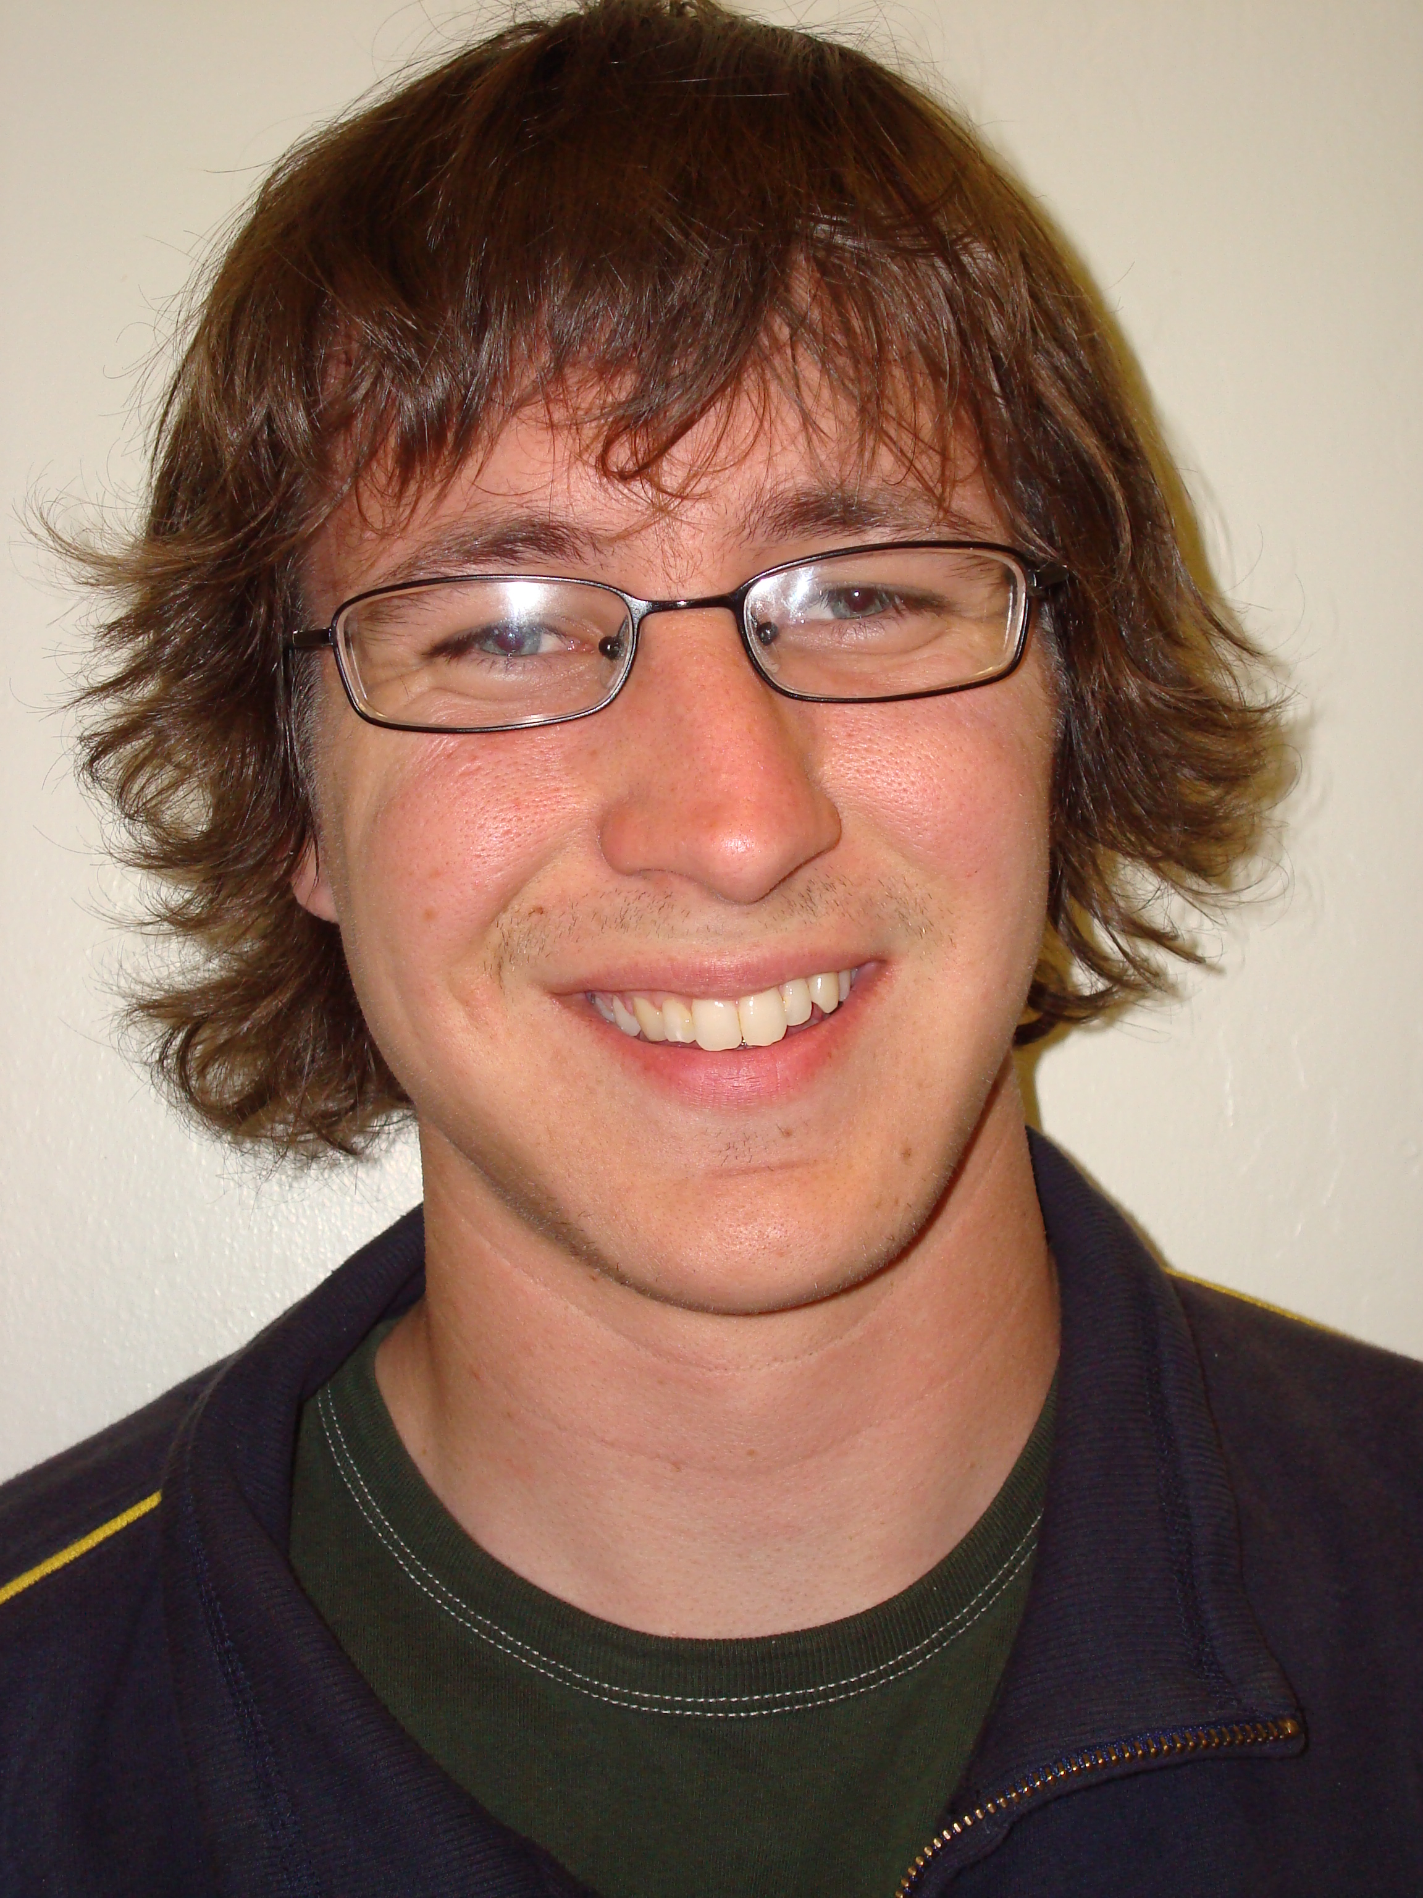
Tony Mercer
University of California-Berkeley
Berkeley, California
Mechanical Engineering / Astrophysics
Bachelor of Science / Bachelor of Art 2009
Email: tonyfig@berkeley.edu

NASA Academy Research Project:
Project Title: Instrumentation Prototyping and
Design for PIPER
Principal Investigator: Alan Kogut, Code 665
Work Experience
- Development Engineer for Romny Scientific Corporation
- Research Assistant at the Space Sciences Laboratory on the TEDI (Triplespec Exoplanet Discovery Instrument) project
- Physics Lab/Teaching Assistant at the Lawrence Hall of Science
- Lab Technician for Hyclone Laboratories
- Astronomy 10 Course Grader and Tutor
- Publication: “Precision Radial Velocities in the Near Infrared with TEDI.” Submitted to IAU 253: Transiting Planets Symposium for May 2008/Cool Stars 15 Meeting for July 2008
Memberships and Activities
- University of California Alumni Leadership Scholars:2003, 2006-2008
- University of California Marching Band: 2003, 2006-2008
- Order of the Golden Bear: 2008
- Cal LDS Student Association: 2003-2004, 2006-2008 President - 2006, Leadership Council – 2003, 2006, 2007
- Full-time volunteer missionary in the Tampa, Florida Mission for the
LDS Church: 2004-2006
- American Society of Mechanical Engineers: 2003-2004
Skills and Certifications
- Adept in LabVIEW programming, including CVI, Vision, Real Time applications, and especially fluent in device control using DAQ, ADC/DAC converters, RS-232, GPIB, and USB communication.
- Programming skills in Matlab, including Simulink, IDL, and exposure to C, developing data analysis software, and control simulations.
- Developed control software, including a PID controller for a robot, and a multi-component system control for TEDI.
- AutoCad and Solid Works modeling skills, including part diagrams, control and harnessing diagrams, and rack diagrams.
- Proficient at using Windows including Microsoft Office and Photoshop, and experienced with Linux.
- Experience using the 5 meter telescope at the Palomar Observatory, the 3 meter telescope at Lick Observatory, and smaller radio dishes
- Basic shop, animal handling, and clean room training
Honors and Awards
- Space Sciences Lab Summer Research Fellowship: 2007
- University of California Alumni Leadership Scholarship: 2007, 2006
- George Miller Cal Band Scholarship: 2007, 2006, 2003
- Pinto/Fialon Portuguese Studies Scholarship: 2008
- Graduate of the Berkeley LDS Institute of Religion: 2008
- USA Today All Academic Team Honorable Mention: 2003
Hobbies and Interests
Waterskiing (both slalom and jump), Swing/Salsa Dancing, Photography, Basketball, Attempting to speak Portuguese, Going to the beach, Fun with family and friends, Traveling, and peering at stars through a telescope.
Personal Statement
I have always wanted to be an explorer, to navigate uncharted waters and witness the unknown. In pursuit of my dreams I have been a part of many amazing organizations, including the TEDI exoplanet search team, the startup thermoelectric company Romny Scientific, the Cal Band, the LDS Florida Tampa Mission, and Call’s Fort Waterski Club, to name a few. My passion for life has brought an array of experiences that bring well-roundedness. I work hard and give all I have to every group I am a part of.
Since I was a young boy I have wanted to work in space exploration, studying the Cosmos. In my astronomy lab I’ve been able to take measurements on the sun, moon, M31, CasA, the large Magellanic cloud, and other objects that are so mysterious and far away. Another of my other great loves is to design and build. It is a very fulfilling experience to solve a problem by designing a device in my mind and then making that design a reality. I’ve worked on designing and building a chess-playing robot, an exoplanet detecting instrument, Rube-Goldberg machines, remote controlled robots, and various other gadgets. My goal is to continue to search the heavens, and hopefully send robots and people into space, to search the unknown.

Kenji Nagaoka
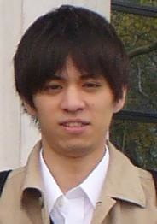
The Graduate University for Advanced Studies
Kanagawa, JAPAN
Major: Aerospace Engineering
Doctor of Engineering, March 2011
Email: nagaoka08@gmail.com

NASA Academy Research Project:
Project Title: GMAT Software Analysis and
Technical Writing
Principal Investigator: Jesse Leitner (Edwin Dove and Steven Hughes)
Code 591
Academic Experience
- Tokyo Metropolitan Institute of Technology, Tokyo, JAPAN
Bachelor of Engineering, March 2006
Work Experience
- Japanese Tutor for foreign students, Fall 2006 – Spring 2007
- Teaching Assistant of the JAXA’s educational programs for high school students, 2006
- Research Assistant, January 2008 – present
- The 9th International Symposium on Artificial Intelligence, Robotics and Automation for Space (i-SAIRAS 2008), CA, US, February 2008
(Title: Drilling Mechanism of Autonomous Burrowing Robot for Lunar Subsurface Exploration)
- Nine national presentations as a first author
(oral and poster, April 2006 - March 2008)
Memberships and Activities
- Soccer Club, April 1995 – March 2001
(I was a team captain, July 1999 - June 2000)
- Student member of the following Japanese societies
(The Robotics Society of Japan, The Japanese Society for Terra-mechanics, The Japan Society for Aeronautical and Space Sciences)
Skills and Certifications
- Computer Skills: Microsoft Office, MATLAB, LaTeX
- Language Skills: Japanese, English (I’m still learning)
- Beginner License: Scuba Diving
- Driver’s License: Car, Motorbike (not international license)
Honors and Awards
- My team placed in top 8 of the National Junior-Youth Futsal Tournament, JAPAN, 1997
- Performance Awards from Miyagi Football Association, JAPAN, 2001
Hobbies and Interests
I love music and soccer (but, now I just watch games on TV). Moreover, I like swimming, scuba diving, reading books and watching movies.
Personal Statement
Space exploration and expansion of human frontier are our important challenges, and taking a role in these fields is my dream. I feel most graceful for the good opportunity to work for NASA. So far, I have studied a development of challenging robotic system for lunar subsurface exploration in my Ph. D. research at JAXA in Japan. This is very exciting task for me (but, it is really hard), and I think challenges are joys of my life. For me, a Japanese student, the NASA Academy is also a new challenge. Meanwhile, now the international connections or interactions are regarded as an important factor for future space development, and I think the global cooperation can lead us to great success. Based on this viewpoint, the NASA Academy would give me several good experiences for my future works.

Florent Nobelen
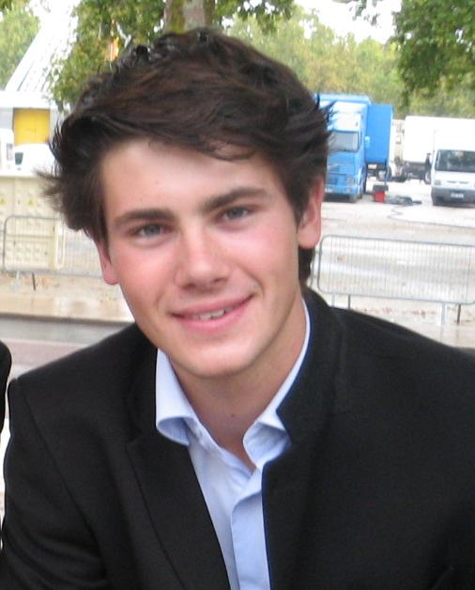
Institut Supérieur de l'Aéronautique et de l'Espace (SUPAERO)
Toulouse, France
Aeronautical and Aerospace engineering
Master of Science, October 2010
Email: florent.nobelen@isae.fr

NASA Academy Research Project:
Project Title: JWST: NIRSpec Detector
Development
Principal Investigator: Chuck Engler, Code 544
Research and Work Experience
- Participation in the ESA Student Space Exploration and Technology Initiative project (SSETI) – European Student Moon Orbiter (ESMO): design of the Star Tracker of the ESMO satellite, implementation in the whole AOCS system (work in a group of four students) – 2007-2008
- Camp counselor in summer camps in France and England (more than 20 weeks in all) – required team work, leadership, initiative and multitask skills, 2004-Present.
Memberships and Activities
- President of Supaéro's Space Club, launch and animation of all space projects:
  - Student Parabolic Flight Campaign (CNES/ESA)
  - Student Aerospace Challenge (ACE): designing of an hybrid engine
  - Participation in a student competition during the Google Lunar X-Prize Team Summit (05/20/08).
- Preparation of an experiment on the inner ear for a parabolic flight (CNES, the French Space Agency) scheduled in Oct. 2008: collaboration with physicians, industry, media; breakthrough opportunity in an unknown innovative scientific domain, 2006-Present
- Member of the Space Tourism Work Group of the AAAF, 2007-Present
- President of the Rock-Salsa club, 2007-Present
- Tutored high school and graduate school students, 2005-2007

Skills and Certifications
- Computer Skills: MS Office, Matlab, Catia, Latex
- Programming: C and Java language
- Language Skills: French (native speaker), English (fluent), Spanish (good)
Honors and Awards
- French Scientific Baccalauréat in Math and Physics, Summa cum Laude
- Won the Safran Prize for the Student Aerospace Challenge, June 2007
Hobbies and Interests
Gliding and Paragliding, Playing the Saxophone, Tennis, Being a camp counselor, Dancing acrobatic rock, Hiking, Skiing, Reading novels, Going to the cinema, Star-gazing, Going to space (one day…), Seeing friends
Personal Statement
Since I was a little boy, I have always been attracted by space and its mysteries. First, I wanted to become an inventor, to imagine new ways to travel quicker and further. As it is not so simple, I realized I preferred to leave this job to other people. I would prefer to be the one who would use the new spacecraft to travel to Mars, which is much more interesting. For this reason, I worked hard after my French Baccalauréat to enter my current University, Supaero, the main French Aeronautical and Aerospace Engineering School. I've continued to work hard to come closer to my dream, without neglecting my friends and my leisure activities: gliding (have you ever watched a mountain from the sky?), music and sports. Thanks to my friends, I manage to stay well-balanced and open-minded. And working at NASA is the first step of achieving a dream.

Michelle Perez
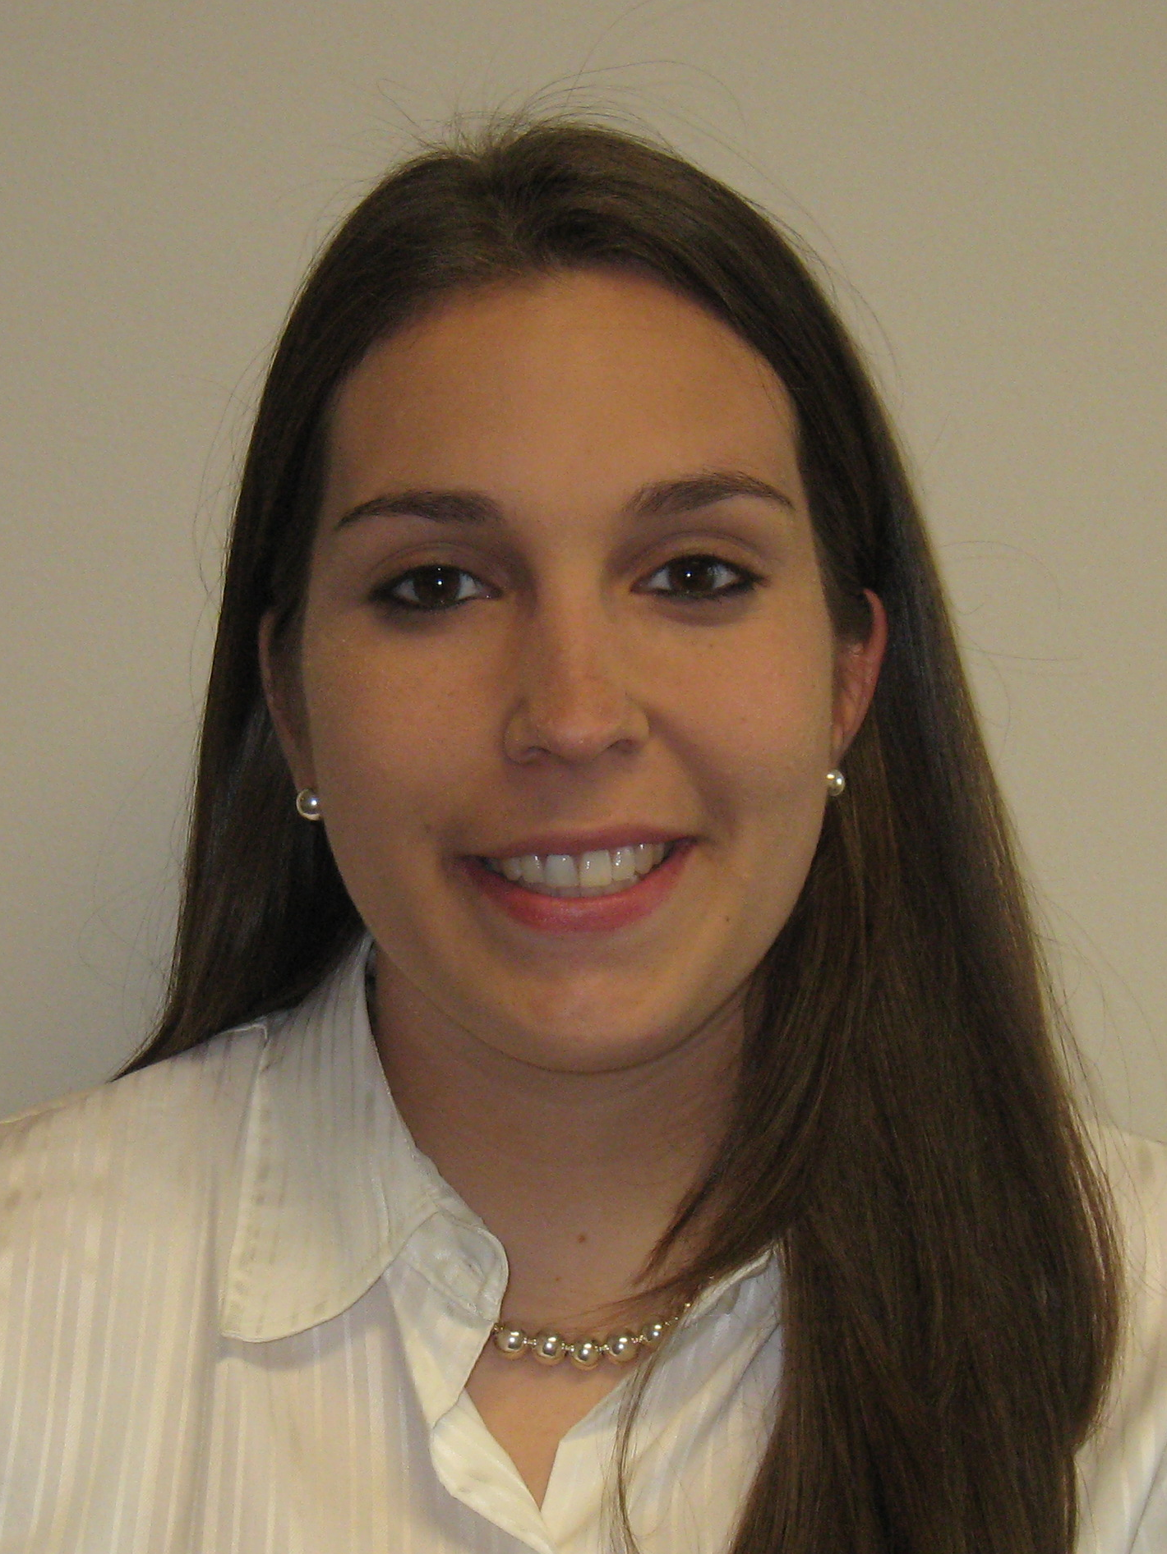
Virginia Polytechnic Institute and State University (Virginia Tech)
Blacksburg, VA
Aerospace Engineering
Bachelor of Science, May 2010
Email: mkperez@vt.edu

NASA Academy Research Project:
Project Title: NPP Mission Readiness, Mission Rehearsal Development
Principal Investigator: Steven Vaclavik, Code 444
Work Experience
- Intern at the United States Department of Agriculture, in the Electric Program in the Power Supply Division, Summer 2007
-Reviewed Construction Work Plans for Power Plants
-Assisted in the Engineering review of Loans for Rural Electric Cooperatives
- Member of the Design, Build, Fly Team at Virginia Tech
-Member of the Wing Team, Fall 2007 to Spring 2008
-Member of the Fuselage Team, Fall 2006 to Spring 2007
-Assisted in the design and construction of an unmanned, electric powered, radio controlled aircraft
Memberships and Activities
- Virginia Tech’s College of Engineering Dean’s Team, Spring 2008- Present
- National Society of Collegiate Scholars, Spring 2007- Present
- Co-Founder of a Rocketry Outreach Program to Local Middle and High School Students in the Blacksburg area
- American Institute of Aeronautics and Astronautics, Fall 2006- Present
- Society of Women Engineers, Fall 2006- Present
- Mentee of the Women in Engineering Support Team, Fall 2006
Skills and Certifications
- Computer Skills: PC, Microsoft Office, working knowledge of Matlab, Adobe Photoshop
- Language Skills: Spanish (Intermediate)
Honors and Awards
- Member of the Phi Kappa Phi Honor Society, Spring 2008- Present
- Recipient of the Davenport Leadership Scholarship, Spring 2007
- Dean's List with Honors, 3 semesters
- University Honors Student at Virginia Tech, Fall 2006- Present

Hobbies and Interests
My hobbies include reading novels, exercising, watching movies with friends, hiking, shopping and scrap booking. I am fascinated by space, history and science. My main interest though is in the development and advancement of manned space exploration.
Personal Statement
"I was born in Northern Virginia, and I have lived in the suburbs of Washington D.C. my whole life. I first became interested in space as a kid after visiting the Smithsonian Air and Space Museum and seeing the displays on the Gemini and Apollo Programs. I continued to be interested in space throughout school and I found my true passion in Aerospace Engineering after completing a summer program in High School called the Virginia’s Governor School for Math Science and Technology. At this program I took an astronomy and engineering based class in which my peers and I tackled the challenges of space exploration when we were given the task of creating a manned a mission to Mars. Ever since that summer I have been fascinated by the challenges of manned space exploration and the rewards that could come from the knowledge that we could gain from manned exploration. My goal is to be on the team of engineers that helps solve this newest set of challenges that NASA faces, and helps further space exploration, by sending man back to the Moon and onto Mars. I hope that NASA Academy will serve as a starting point for this goal. Working for NASA has been a dream of mine, and I am very excited and honored to be a part of NASA Academy this summer."

Maxime Rizzo
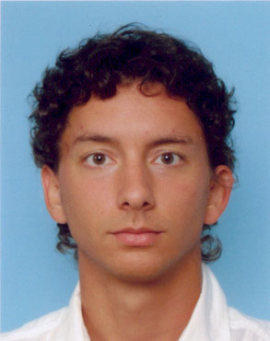
Institut Supérieur de l'Aéronautique et de l'Espace (SUPAERO)
Toulouse, FRANCE
Aeronautical and Aerospace Engineering
Master of Science, October 2010
Email: maxime.rizzo@gmail.com

NASA Academy Research Project:
Project Title: Visible Nulling Coronagraph Testing and Calibration for ExoPlanet Detections
Principal Investigator: Rick Lyon, Code 667
Research and Work Experience
- Research Project related with CNES (French Space Agency) : definition and optimization of a constellation of satellites for the detection of ionospheric earthquake precursors over key regions ; design of a complete mission proposal (work in a group of four students) – Toulouse, France, 2007-2008
- Guide in the famous French space museum, the “Cité de l'Espace” ; guided tours in English and French – Toulouse, 2007-2008
Memberships and Activities
- President of the regional Youth Committee of the AAAF (the French Aerospace Professional Association) ; leading a large group of students to share our passion for aeronautics and space
- Member of the Space Tourism Work Group of the AAAF
- Member of the SUPAERO Association for Space “Club Espace”
- Water rockets (building and launching) activities with a class of 9-year old children – Spring 2008
- Coordinator of Communication in the Air Expo association, a big French free Air Show (35000 visitors) – 2006-2007
- President of SUPAERO Association for Culture and Arts – 2006-2007
- Member of the Writing Workshop “Le Bistrot Littéraire”
Skills and Certifications
- Computer Skills: Microsoft Office, Linux, Matlab, Adobe Dreamweaver, Adobe Photoshop
- Programming : C, JAVA
- Language Skills: English (fluent), German (average), Chinese (beginner)
Honors and Awards
- French Scientific Baccalauréat in Maths and Physics, with distinction
Hobbies and Interests
wandering in cities; theatre; improvisation shows; literature; music; writing; looking at things or people; sailing; tennis; seeing rocket launches; astrophysics
Personal Statement
My parents have a house in the countryside, near Strasbourg, with a perfect clear sky with shiny stars. Maybe that was enough to give me the passion for space, very early in my life. Of course, as I first dreamt of becoming an astronaut, I did not imagine I would go and work for NASA one day. It was too far for me, little French boy, even if I was extremely ambitious. But I never let the dream go away. At the end of my undergraduate studies, I had the necessary theoretical background to enter any French Engineering School. I chose the French Graduate School of Aeronautics and Space (SUPAERO engineering studies), where I spent the most intense moments of my academic experience. I was learning what I liked, and got involved in several associative projects, where I met several great friends and colleagues and where I have learnt so much about “human relations”. I managed to stay close to Culture and Arts, from which I have always learnt a lot about life and philosophical questions, and which are necessary for my brain to keep being inventive. In second year of my engineering studies at SUPAERO, I entered the tiny space community in France. I have tried to get involved in several serious space projects. I have never been closer to my passion, and the more I learn the more I think I will dedicate my whole life to it. In December 2007, I took my chance applying for NASA Academy, and now I am here. I want to do my best in order to deserve the great opportunity that is offered to me, and use my energy to make this summer at the Academy the most exciting of my life.

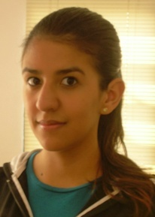
Lisha Roubert
University of Puerto Rico, Cayey
Cayey, Puerto Rico
Major: Mathematics
Bachelor of Science, June 2009
Email: roubert08@hotmail.com

NASA Academy Research Project:
Project Title: Modification of the Graphical User
Interface (GUI) for the EDOS
webpage
Principal Investigator: Rose Wood, Code 444
Work Experience
- NASA GSFC Summer Institute on Atmospheric, Biospheric and Hydrospheric Sciences 2007, Code 614.6 Instrumentation Sciences Branch, Research Assistant
Memberships and Activities
- Circle of Mathematics Student Organization, Sub-secretary 2007-2008
- Student member of the American Geophysical Union (AGU), Present 2008
Skills and Certifications
- Computer Skills: Windows, Linux, Excel, Power Point, MATLAB Python, SciTE Source Code Editor (to some extent)
- Mathematical Skills: Calculus I through III, Ordinary Differential Equations, Elementary Statistics, College Geometry, Modern Algebra, Programming
- Language Skills: Fluent in Spanish and English
- Lab skills in Astronomy, Biology, Chemistry and Physics
Honors and Awards
- Dean’s list, 2008
- Graduated 2nd (Salutatorian) from S.A.D.L. High School Class, May 2005
Hobbies and Interests
My academic areas of interest involve diverse areas such as astronomy, cryospheric sciences, mathematics, meteorology, oceanography and physics. In regards to extracurricular activities I enjoy tennis, photography and reading crime fiction novels.
Personal Statement
“Space science has always been of particular interest to me even though I have barely had the opportunity to explore the depth of the achievements accomplished in this area. Thankfully, I have been granted the privilege to participate in NASA Academy, an experience that will give me the opportunity to learn about the Space Industry and expand my knowledge in different directions which is my main goal for the future. I draw my inspiration from the brilliant minds of the past, their knowledge and discoveries transcended their area of expertise which has opened the way for humankind to accomplish the unthinkable. I have decided to begin with a mathematics career due to the fact that it is the base of all other areas related to science. This dependent relationship upon mathematics leads me to believe that the world possesses certain symmetry and in order to maintain it in this state of equilibrium a profound knowledge of numbers is required. This is my own philosophy and the main reason why I consider that studying mathematics will help me become a better meteorologist which is the career I wish to pursue. However, despite my aspirations of becoming a meteorologist I have always been fascinated by space science so I definitely look forward to this unique internship opportunity. I may feel a little unprepared because of my limited experience in the aerospace area but, I always look forward to taking on challenges since these are the experiences that one most gains from. Now that I have been given this opportunity I will not take it for granted and will work very hard. I look forward to the day when I can look back upon this and remember the valuable lessons learned while working for the most prestigious Space Industry that stands out for its innovation, NASA.”

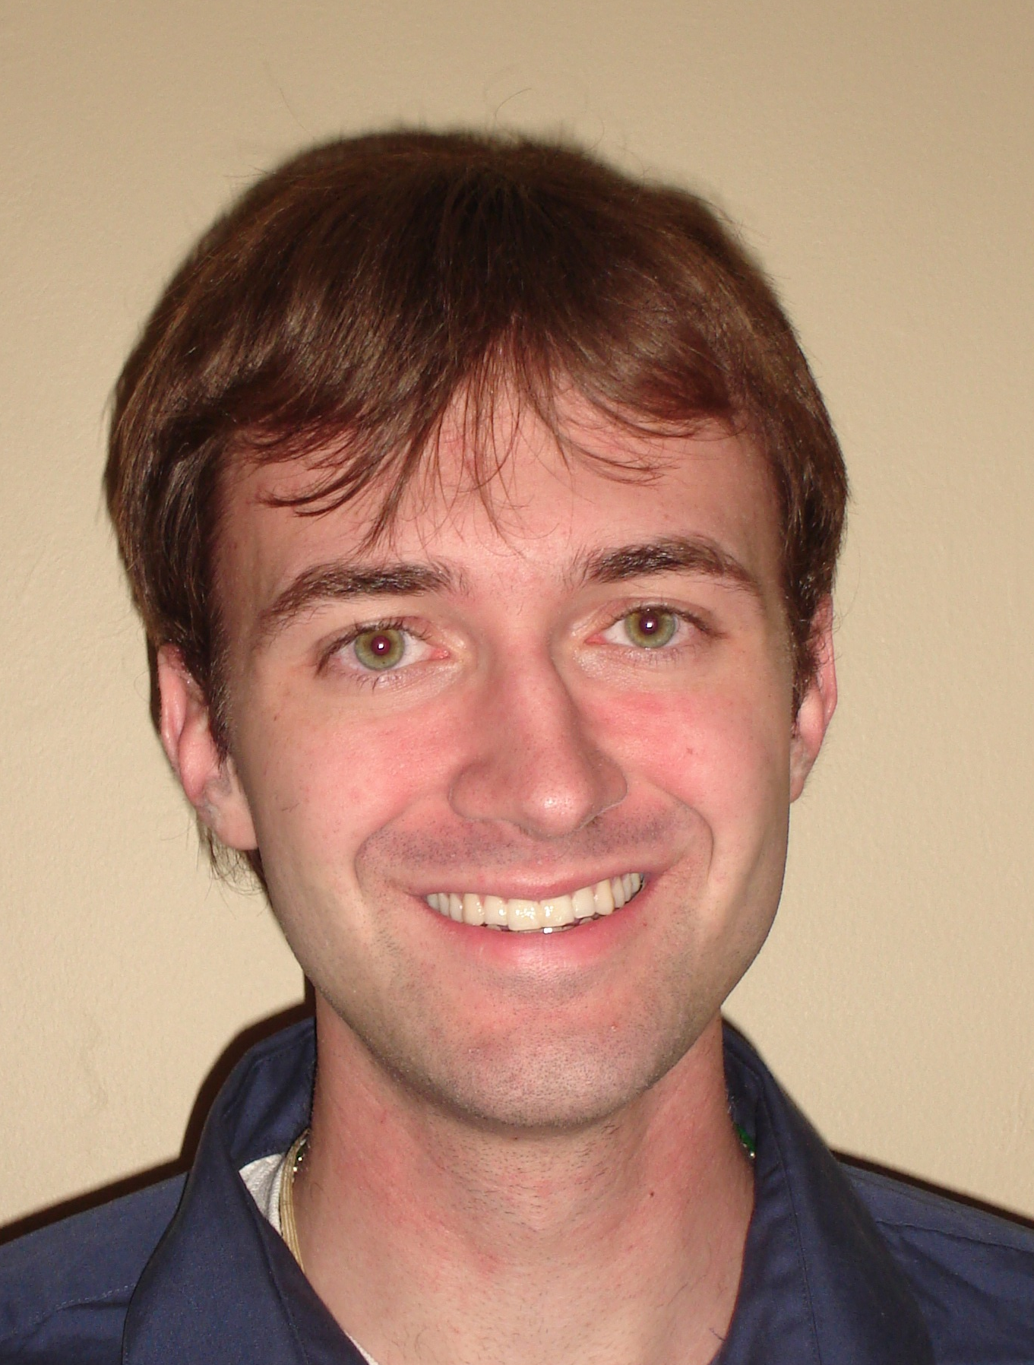
Andrew Schaeperkoetter
University of Kansas
Lawrence, Kansas
Aerospace Engineering
Bachelor of Science, May 2009
Email: thrawn77@ku.edu

NASA Academy Research Project:
Project Title: GMAT Software Analysis and
Technical Writing
Principal Investigator: Jesse Leitner (Edwin Dove and Steven Hughes)
Code 591
Work Experience
- Undergraduate Researcher working on building, assembling, testing, and calibrating calorimeter for CERN (particle accelerator)
- Undergraduate Researcher to create a model of the atmosphere and how variable densities affect satellite orbits
- Supervisor and Railroad Conductor at Saint Louis Zoo
Memberships and Activities
- Tau Beta Pi, Spring 2007-Present
- Sigma Gamma Tau, Spring 2007-Present
- American Astronautical Society (AAS), Fall 2005-Spring 2007
- St. Lawrence Catholic Campus, Fall 2005- Present
- Honors Program, Fall 2005- Present
- KU Students For Life, Spring 2006-Present
- Sacred Heart Parish Catechist for 8th grade boys, Fall 2007-Present
- Men’s Glee Chorus, Fall 2005-Spring 2007
Skills and Certifications
- Computer Skills: Microsoft Office, Visual Basic for Applications, UNIX, Unigraphics, Nastran, Concepts, Linex, Matlab
Honors and Awards
- Eagle Scout, Fall 2001
- National Merit Finalist, Spring 2005
- University Scholar, Honor given to top 20 sophomores of KU, Fall 2006
- Undergraduate Research Award, Fall 2007
- Undergraduate Research Award, Spring 2008
Hobbies and Interests
Star-gazing, Swimming, Reading, Playing board games, Playing video games, Singing, Seeing plays and musicals, Praying, Playing sports for fun especially soccer, Vacationing to parks and museums, Painting ceramics, Roller Coasters
Personal Statement
"When I was very young, my family went on vacation to Florida. We watched the space shuttle Discovery launch on that trip, and though we were told by the locals that it was one of the worst launches they’d seen due to the clouds, the exploration of space has held my complete fascination ever since. My hope is to become an astronaut, a dream I’ve had since watching that shuttle launch. Since childhood, I’ve had a constant drive to understand the unknown in all its forms, a characteristic that manifests itself in my frequent questioning and curiosity."

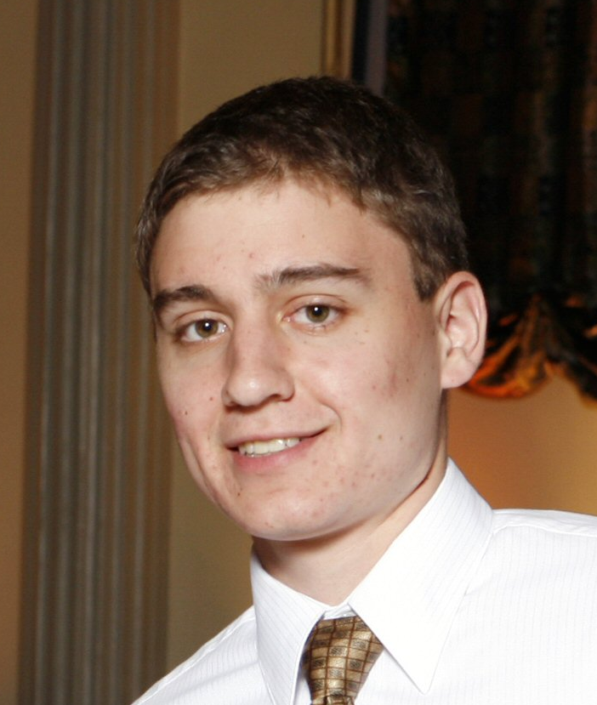
John Springmann
University of Wisconsin, Madison

Madison, WI
Engineering Mechanics and Astronautics
Bachelor of Science, May 2009
Email: john.springmann@gmail.com

NASA Academy Research Project:
Project Title: JWST: Characterization and
Development of an IR camera and
Detector for Microshutters Contrast Evaluation
Principal Investigator: John Chambers, Code 551

Research and Work Experience
- Univ. of Wisconsin Solid Mechanics Lab, 2007-present, characterizing the force response of hydrogels for use in microfluidic devices
- NASA Reduced Gravity Student Flight Opportunities Program, 2008, investigating the effectiveness of linear spray cooling in microgravity
- NASA Reduced Gravity Student Flight Opportunities Program, 2007, investigating fluid flow due to capillary action in microgravity
- Univ. of Wisconsin Solid Mechanics lab, 2006-2007, assisted in research on the mechanical properties of shape memory alloys (SMAs) and SMA-polymer composites

Memberships and Activities
- American Institute of Aeronautics and Astronautics (UW Chapter treasurer, 2007-2008)
- UW ZeroG Team (Team Leader , 2007-2008)
- Study Abroad Program, Toulouse, France, summer 2006
- University Symphony Orchestra, 2005-2006
- Intramural Tennis and Ultimate Frisbee

Skills and Certifications
- Software: Ansys, Abaqus, Matlab, MathCAD, AutoCAD
- Programming: Java, Visual Basic, HTML
- Machining: Basic knowledge of mill, lathe, CNC code
- Languages: Proficient in French

Honors and Awards
- Recipient, Rod and Diana Lakes Scholarship in Engineering Mechanics
- Recipient, Hilldale Undergraduate Research Fellowship
- Recipient, Wisconsin Academic Excellence Scholarship
- Member, Tau Beta Pi Engineering Honor Society
- Honors in Undergraduate Research Program

Hobbies and Interests

Camping and other outdoor activities, traveling, playing violin, classical music, Badger football, hang gliding, human space flight

Personal Statement

I enjoy getting involved in many things outside of class including various research projects, student organizations, and other activities. One of the reasons I am interested in aerospace and spaceflight is that I enjoy being challenged. As President Kennedy said, “We choose to go to the moon in this decade and do the other things, not because they are easy, but because they are hard…” I am very excited to have the opportunity to contribute to NASA’s work.

Michelle Sybouts
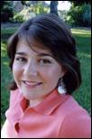
University of Washington
Seattle, Washington
Atmospheric Sciences
Bachelor of Science, June 2010
Email: syboum@u.washington.edu

NASA Academy Research Project:
Project Title: Mars Analog Chemical Analysis in
Preparation for the 2009 Mars Science
Laboratory Investigations
Principal Investigator: Paul Mahaffy, Code 699
Work Experience
- ZaP Flow Z-Pinch Experiment University of Washington (June 2006 - Current)
- NASA Space Grant Summer Undergraduate Research Program (SURP) (June- August 2006)
Memberships and Activities
- Students for the Exploration and Development of Space (SEDS)
(October 2006--current)
- Engineers Without Borders -- University of Washington Chapter (October 2007--current)
- Women in Science and Engineering (WISE) panel member (May 2007)
- American Institute of Aeronautics and Astronautics (AIAA) -- 3rd place at the student conference in San Jose University for technical paper and presentation on my work in ZaP Lab (April 2007)
- Washington NASA Space Grant Reception and Poster Session
(October 2006)
- Annual Undergraduate Research Symposium (May 2007)
- Classically trained flutist
- Community service -- over 550 hours to date
- Stage Crew for the premier of University of Washington's
“Fair Play”
Skills and Certifications
- Machine Shop Safety Qualified
- SolidWorks
- Basic JAVA programming
Honors and Awards
- NASA Space Grant Scholar
- Washington Scholar
- Dovie-Samuelson Scholar
- Honors College student at University of Washington
- Early entry to College of Engineering at the University of Washington (admitted immediately after high school)
- YWCA Outstanding Young Woman of Achievement Award 2005
- United Way Volunteer Family of the Year 2006 -- for outstanding community service contributions
Hobbies and Interests
Playing my flute, playing soccer with friends, acting, drawing, writing, travel, and as much community service as possible
Personal Statement
“There are no footsteps on mars... yet.

With my ultimate goal being to become an astronaut, my passion is to positively affect humanity and our world through scientific advances, specifically through space exploration and its applications here on earth.

Now in my second year at University of Washington, I am completing research in a plasma physics lab, as well actively supporting groups such as Engineers Without Borders and Students for the Exploration and Development of Space. Just as the great scientists before me pushed the envelope of development, I wish to move beyond what is known. The progression of the human race stems from our innate desire to explore. My passion is to boldly venture beyond the known, the accepted, and the limits of the human race and see what can be done!”

Alan Talbott
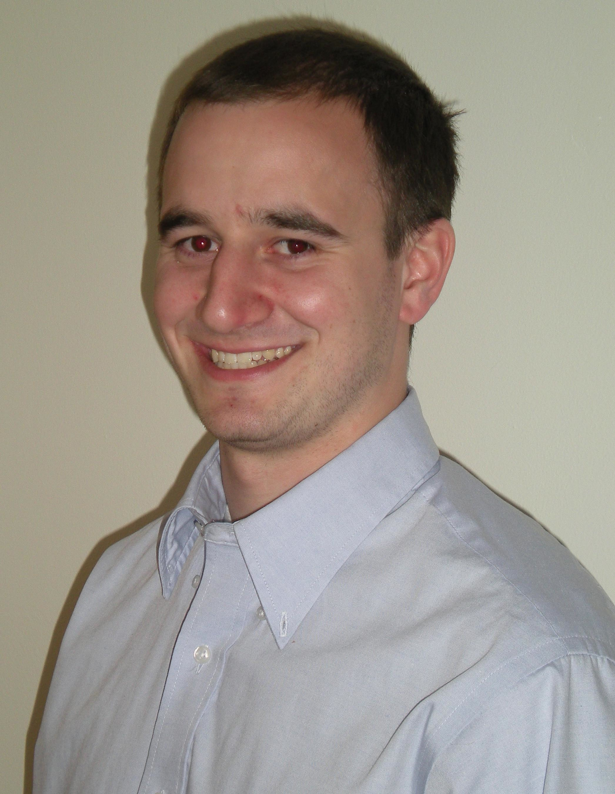
West Virginia University
Morgantown, WV
Aerospace Engineering and Mechanical
Engineering
Bachelor of Science, December 2009
Email: talbat18@gmail.com

NASA Academy Research Project:
Project Title: GOES N-P Weather Satellite System
Data Analyses
Principal Investigator: Kenneth Yienger, Code 599
Work Experience
- NASA, Reduced Gravity Student Flight Opportunities Program, “Investigation of Viscous and Capillary Fingering Through A Hele-Shaw Cell In Microgravity,” 2008
- NASA, Reduced Gravity Student Flight Opportunities Program, “Investigation of Circular Hydraulic Jump Behavior In Microgravity,” 2007
- Residential Education West Virginia University, Resident assistant in the engineering dormitory, 2006-Present
- Cambrex Bio Science Inc., Mechanical engineering intern, 2006
- Lonza Inc., Project engineering intern, 2007
Memberships and Activities
- Tau Beta Pi Engineering Honorary, 2007-Present
- Sigma Gamma Tau Aerospace Honorary, 2006-Present
- Mortar Board Senior Honorary, 2008-Present
- WVU Microgravity Research Team, 2006-Present
- WVU Honors College, 2005-Present
- Engineering study group tutor, 2006-Present
- National Space Society 2007-Present
- Resident Assistant Council, 2007-Present
- Mountaineer Maniacs, 2005-Present
Skills and Certifications
- Computer Skills: Microsoft Office, MATLAB, HTML, C++, Pro|Engineer, AutoCAD, Fluent FlowLab
- United States Soccer Federation, Grade 8 Referee, 2003-2006
- National Soccer Coaches Association of America, Regional Coaching Certification, 2001-Present
Honors and Awards
- WVU Presidential Scholarship, 2005-Present
- Lloyd B. Selby Scholarship, WVU College of Engineering, 2006-2007
- Edwin Bjornson Scholarship, WVU College of Engineering, 2006-2007
- California Grocers Association Scholarship, 2006-2008
- Illuminators Scholarship, 2005
- Maryland Senatorial Scholarship, 2005-Present
- Long and Foster Scholarship, 2005-2006
- President’s List, 4 Semesters
- Dean's List, 1 Semester
Hobbies and Interests
Soccer, snowboarding, rock climbing, intramural dodgeball, reading Wikipedia, playing Wii, listening to music
Personal Statement
At the age of 8, a family friend bought me my first model rocket kit. After building and launching my first rocket, I was hooked. As my love for aeronautics grew, I knew I was going to become an engineer. I have been fortunate to have so many great opportunities through NASA and WVU. For the past two years I have been a member of the Microgravity Research Team at WVU and have successfully proposed, designed and built two separate experiments that were flown on NASA’s C-9 Weightless Wonder at Johnson Space Center. I am grateful to now be a part of the 2008 NASA Academy at GSFC. I hope to someday find a career in the aerospace industry and truly make a difference in the field.

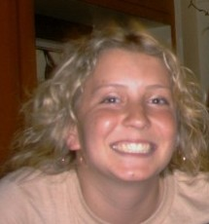
Jessica Tramaglini
Penn State University
University Park, PA
Aerospace Engineering
Bachelor of Science, May 2009
Email: jrfd09@gmail.com

NASA Academy Research Project:
Project Title: GPM Spacecraft Preliminary Design
Principal Investigator: James Parker, Code 543
Work Experience
- NASA Langley Aerospace Research Summer Scholars (LARSS) intern 2007
  - NASA Technical Papers (NASA-TP) or NASA Educational
Reports (NASA-ER):
    - Jessica K. Tramaglini, Francis F. Badavi,“Low Earth Orbit Radiation Environments and Shield Model Validation for ISS”, NASA Langley Research Center, LARSS Program, August 2007.
  - Conference Papers:
- Francis F. Badavi, Jessica K. Tramaglini, John E. Nealy, John W. Wilson,“Low Earth Orbit Radiation Environments and Shield Model Validation for ISS”, AIAA Space 07, AIAA 2007-6046, Long Beach, California, September 18-20, 2007, available through http://www.aiaa.org /.
- NASA Spaceflight and Lunar Sciences and Technology Program (SLSTP) intern 2006
- Team lead, NASA Reduced Gravity Student Flight Opportunities Program 2008 Penn State team
- Outreach coordinator, NASA Reduced Gravity Student Flight Opportunities Program 2007 Penn State team
- Thermal/mechanical team member, Penn State High Altitude Student Platform (HASP) team
Memberships and Activities
- President of the AIAA Penn State branch 2007-2009
- Secretary of the AIAA Penn State branch 2006-2007
- Penn State Engineering Leadership Development Unlimited chair of Imagin8 leadership conference 2007
- Society of Women Engineers Penn State section homecoming chair 2007
- Penn State Women in Engineering Program Orientation leadership team 2006-2008
- Penn State College of Engineering coop/internship envoy
- Penn State Engineering Mentorship Program mentor 2006-2008
- Penn State LeaderShape® 2008
Skills and Certifications
- Computer Skills: Microsoft Office, Frontpage, CATIA, ANSYS, ABAQUS, Visual Basic, C++, MATLAB, Alibre, SigmaPlot, Fireworks, Dreamweaver
- Language Skills: Spanish
- Penn State College of Engineering Space Systems Certificate
Honors and Awards
- Schreyer Honors College
- Sigma Gamma Tau Aerospace Engineering Honors Society
- Penn State Women in Engineering Joelle Leadership Award 2008 Honorable Mention
- Penn State SWE most active upperclassman 2007
- Penn State SWE most active underclassman 2006
- President’s Freshman Award 2006
Hobbies and Interests
Star-gazing, music, movies, dancing, shopping, reading
Personal Statement
I attended Space Camp when I was twelve years-old, and that changed everything. Since then it has been my goal to work in Mission Control at Johnson Space Center. My passion for space exploration has only grown through my experiences working at Kennedy Space Center and Langley Research Center. I have also been fortunate to participate in the Reduced Gravity Student Flight Opportunities Program at Johnson Space Center. These experiences have really broadened my horizons and have taught me many skills that I hope to someday apply to further space exploration. I try to live life to the fullest, and wherever it may take me, I’ll be content as long as I can contribute to human spaceflight.

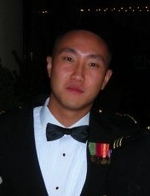
Zhen Zhao
University of Maryland

College Park, MD (Fall 2008)

Bachelor of Science, June 2010

United States Naval Academy
Annapolis, MD (2006-2007)

Aerospace Engineering
Email: zhen.zhao6@gmail.com

NASA Academy Research Project:
Project Title: GOES N-P Weather Satellite System
Data Analyses
Principal Investigator: Kenneth Yienger, Code 599
Work Experience
- Enlistment in the United States Marine Corps (2002-2006, Sergeant)
- Air Traffic Control Radar Watch Supervisor and Tower Controller, Marine Corps Air Station New River (2003-2006)
Memberships and Activities
- Member, American Institute of Aeronautics and Astronautics (2008)
- Member, Society of American Military Engineers (2008)
- Member, National Society of Collegiate Scholar (2006-Present)
- Member, Midshipmen Action Group (Fall 2006)
- Volunteer, Harvard Square Homeless Shelter (Spring Break 2006)
- Volunteer, Special Olympics (Fall 2005)
Skills and Certifications
- Computer Skills: Working knowledge of Microsoft Office and MATLAB
Honors and Awards
- Noncommissioned Officer of the Year 2005, United States Marine Corps
- Noncommissioned Officer of the Quarter 2005, United States Marine Corps
- Meritorious promotions Private through Sergeant, United States Marine Corps (2003-2006)
- Navy and Marine Corps Achievement Medal (2005)
- Superintendent’s List, United States Naval Academy (Spring 2007)
- Dean’s List, United Sates Naval Academy (Fall 2007)
- Commandant’s List, United States Naval Academy (Spring 2008)
- Nominated Midshipman of the Semester, United States Naval Academy (Spring 2007)
Hobbies and Interests
Reading, working out, swimming, handball, rock climbing, piano and guitar, drawing, the universe in general, New Yorker cartoons
Personal Statement
Space has always interested me ever since I took my first airplane ride at the age of six. Since then, I imagined myself one day traveling to some distant star and living there; childhood fantasies can be a bit ridiculous sometimes but also a source of great inspiration. I was born in Beijing, China, and grew up in Shanghai. When I was six, my family moved to Queens, NY, where I spent my teenage years. I spent my teenage years growing up in the city and attended Stuyvesant High School. Witnessing the tragedy of September 11th firsthand, I decided it was time to put aside my dream and decided to take my place in those famous yellow footprints at Parris Island on September 10, 2002. The four years that I spent in the Marine Corps gave me a sense of responsibility, discipline, and maturity that I will never take for granted. Soon afterwards, I applied to the United States Naval Academy where I was accepted into the Class of 2010. Figuring that I was in one of the best engineering schools in the nation, I decided to major in aerospace engineering and pick up where I left off four years ago. I look forward to spending this summer with the 2008 NASA Academy and meeting people who are just as passionate about space research as I am. This will be my first experience in the aerospace community and I am grateful to the Academy for granting me this opportunity.

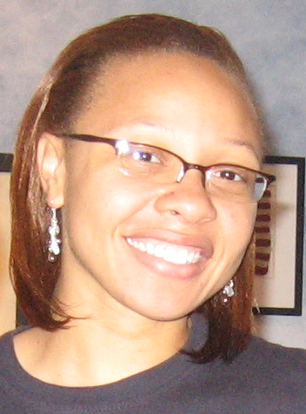
Program Coordinators

Sherrica Newsome
Operations Manager:
NASA GSFC Academy 2007 Alumna

Massachusetts Institute of Technology
Cambridge, MA
Technology and Policy
Masters of Science, June 2010
Email: snewsome@mit.edu
Sherrica graduated from Virginia Tech in December of 2007 with a Bachelors of Science in Aerospace Engineering and a minor in Mathematics. She will pursue a Masters of Science in Technology and Policy beginning the fall of 2008 at Massachusetts Institute of Technology. This degree will prepare her to take on leadership roles that confront important technological issues within society. Sherrica is interested in policy ethics and international affairs. Apart from her academics, Sherrica loves music, singing, laughing, reading, and spending time with family and friends.

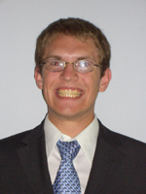
Tim Montague
Logistics Manager:
NASA GSFC Robotics Academy 2005 Alum

Montana State University
Bozeman, MT
Computer Engineering
Bachelors of Science, May 2009
Email: Tim.Montague@gmail.com

Tim’s focus is robotics. He has been a member of both the Robotics Academy and the Student Internship Program at Goddard as a part of teams building robots. In the summer of 2007, Tim worked on human-robot interfaces at AnthroTronix in Silver Spring, MD. In his spare time, he enjoys programming microcontrollers, hiking, rock climbing and snowboarding.
Staff
The NASA Goddard Academy is administered and operated within the GSFC Office of Higher Education.

Chief, Office of Higher Education- Dr. Vigdor L. Teplitz
Dr. Teplitz directs the Office of Higher Education and other programs offered by the Office. He joined Goddard at the beginning of 2003 on a three-year leave of absence from the Physics Department of Southern Methodist University. His previous experience includes academic appointments at MIT and Virginia Tech, 12 years in the U.S. Arms Control and Disarmament Agency, and two years in the White House Science Office. His research is in elementary particle theory, primarily at its border with astrophysics and cosmology.

Deputy Chief, Office of Higher Education- Dr. Richard P. Fahey
Dr. Fahey serves as Deputy Chief of the Office of Higher Education. Prior to Dr. Teplitz's arrival, he led the Office of Higher Education as Acting Director for several years both before and after Jerry Soffen's death. For the past three decades, he has been developing methods of presenting aspects of relativity and quantum theory to specialist and non-specialist audiences. During that time, he has taught courses in physics, astronomy, relativity and cosmology, aerospace engineering, and the philosophy of nature. Dr. Fahey currently conducts research in cosmology and gravitational wave detection at GSFC. He is also the Naval Space Command Research Chair at the U.S. Naval Academy in Annapolis.

Program Director - Mr. David Rosage
Mr. Rosage (ME) has served NASA in various technical roles between 1980 and 2000, and as Director/Program Manager of the Academy since 2000. Besides managing the NASA Academy Program for Goddard, he is responsible for short and long-term program improvements, expansion of the Academy to other NASA centers, enabling international participants, and increasing Academy alumni involvement and their awareness to the NASA community.

Program Manager - Dr. Mildred Lockhart-Boyd
Dr. Boyd serves as the Program Manager for LUX Consulting Group, a contractor for the Office of Higher Education at NASA GSFC, and provides direction, implementation and management to the programs offered by the Office. She has provided support to student programs at Goddard since 1999. She also served on the first support team to the first NASA Academy in 1993.
Dr. Boyd received her Ph.D. from Michigan State University in Science and Mathematics Education, Masters of Science from Howard University in Microbiology, and Bachelors of Science from Howard University in Botany.

Dean of Academic Affairs - Dr. Joseph Di Rienzi
Joseph Di Rienzi is a Professor of Physics at the College of Notre Dame in Maryland and a Visiting Scientist at NASA/Goddard Space Flight Center’s Laboratory of Astronomy and Solar Physics. Dr. Di Rienzi received his Ph.D. in Physics form the Polytechnic Institute of New York and his B.S. from Brooklyn Polytechnic Institute. His research interests are in theoretical physics, in particular atomic physics and the foundations of quantum mechanics. He works at Goddard with Dr. Richard Drachman on theoretical modeling of matter-antimatter reactions, and currently they are investigating the scattering of positronium with helium. Dr. Di Rienzi has had a long association with the NASA Academy. He served under Dr. Soffen as the original Dean in 1993 and 1994. He returned again as the Dean in 1999 and has remained in that position since 2004. Dr. Di Rienzi is a long time member of the Selection Committee, and he is very excited to be part of this year’s Academic Staff.

Program and IT Support - Mr. Johnny Erickson
Johnny has a B.S. in Computer Science and is the co-founder of a software design company. Johnny is an enthusiastic and devoted supporter of the Academy and its alumni.

Program Coordinators – Tiffany Russell and Sherrica Newsome
In the operation of the NASA Academy, Tiffany and Sherrica will provide general assistance and logistics coordination. They will reside full time at the Academy House and will be available as facilitators in relevant program activities.

Together with the designated Academy staff listed above, the Academy participants are expected to be actively involved in the affairs of the Academy, assuring its day-to-day success.

All the members of the Office of Higher Education will be pleased to grant any assistance and support needed.

Links

- NASA Academy:
http://academy.nasa.gov/

- NASA Academy Alumni Association:
http://www.nasa-academy.org/

- NASA Agency:
http://www.nasa.gov

- International Space University:
http://www.isunet.edu

- The Soffen Memorial Fund:
http://www.nasa-academy.org/soffen/donors.html

- Goddard Space Flight Center:
http://www.gsfc.nasa.gov/

- Goddard Space Flight Center's Mission:
http://www.gsfc.nasa.gov/about_mission.html

